**ggUNIT-IV**

**What is a Cloud Service Models?**

Cloud service models refer to the different ways cloud computing services are delivered and consumed. These models provide various levels of abstraction, management, and responsibility between the service provider and the user. The three primary cloud service models are

The National Institute of Standards and Technology (NIST) defines three basic service models, namely, IaaS, PaaS, and SaaS, as shown in Figure

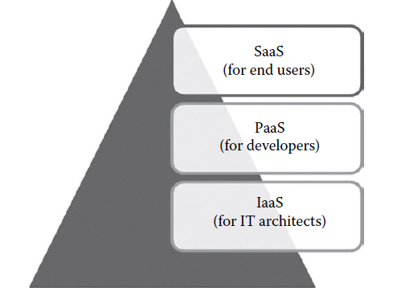

* Infrastructure as a Service (IaaS)
* Platform as a Service (PaaS), and
* Software as a Service (SaaS).

Each model offers a different set of capabilities and responsibilities for users and providers.

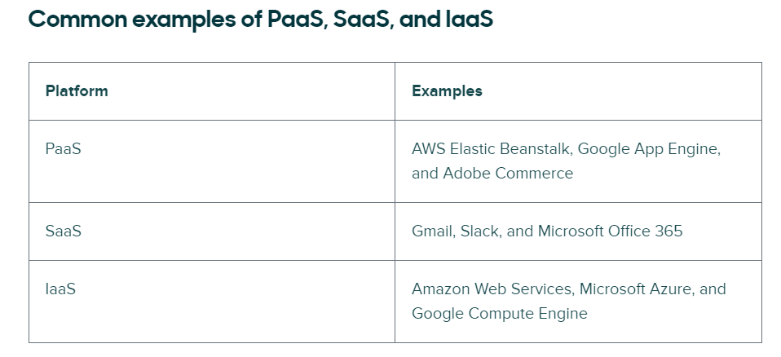

**Infrastructure as service (IaaS)**

Infrastructure as a Service (IaaS) is a cloud computing model that provides virtualized computing resources over the internet. In simpler terms, it offers virtualized computing infrastructure that can be rented out and accessed on-demand. This infrastructure includes servers, storage, networking, and other fundamental computing resources, allowing users to build and manage their own IT platforms without having to invest in physical hardware.

**The key components of IaaS:**

IaaS providers use virtualization technology to create virtual instances of physical hardware resources. This allows multiple users to share the same physical hardware while maintaining isolation and security between different users' virtual environments. Users can create virtual machines (VMs) with specific configurations (CPU, RAM, storage, etc.) based on their requirements.

**Compute:** IaaS providers offer scalable compute resources in the form of virtual machines or containers. Users can choose the type and size of virtual machines based on their processing power, memory, and storage needs. These virtual machines can be provisioned, managed, and scaled up or down dynamically, allowing users to adapt to changing workloads and demands.

**Storage:** IaaS platforms provide scalable storage solutions that can accommodate various types of data, including structured, semi-structured, and unstructured data. Users can store files, databases, and other data types in the cloud, with options for block storage, object storage, and file storage. Storage resources can be scaled up or down as needed, and data is typically replicated across multiple locations for redundancy and fault tolerance.

**Networking:** IaaS providers offer networking services to connect virtual machines, storage, and other resources within the cloud environment. Users can set up virtual networks, subnets, and firewalls to control traffic and ensure security. Additionally, IaaS platforms often include load balancers, DNS services, and other networking features to optimize performance and availability.

**Security:** Security is a critical aspect of IaaS, and providers implement various measures to protect data and resources. This includes encryption for data in transit and at rest, identity and access management (IAM) for controlling user access to resources, network security controls such as firewalls and intrusion detection systems (IDS), and compliance certifications to meet regulatory requirements.

**Load balancers:** Load Balancing as a Service may provide load balancing capability at the infrastructure layer.

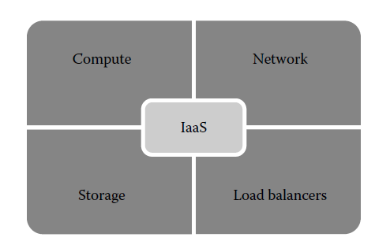

**Characteristics of IaaS**

1. **On-Demand Self-Service:**

* **User Control:** Users can provision, configure, and manage computing resources through a self-service portal or API without needing human intervention from the service provider.
* **Rapid Provisioning:** Resources can be quickly provisioned and de-provisioned, enabling rapid scaling up or down according to demand.

1. **Scalability and Elasticity:**

* **Dynamic Scaling:** IaaS allows automatic scaling of resources in response to changing workloads. This elasticity helps manage peak loads efficiently and reduces costs during low-demand periods.
* **Wide Range of Options:** Users can choose from various configurations and sizes of virtual machines, storage capacities, and network setups.

1. **Pay-Per-Use Pricing:**

* **Consumption-Based Billing:** Users are charged based on their actual usage of resources. This can include compute hours, storage space, and data transfer amounts.
* **Cost Efficiency:** By paying only for what they use, organizations can optimize costs and avoid the expenses associated with maintaining unused or underutilized hardware.

1. **Flexible Resource Allocation:**

* **Customizable Environments:** Users can configure virtual machines, networks, and storage to meet specific needs, allowing for tailored IT solutions.
* **Resource Management:** Administrators can allocate resources dynamically based on application performance requirements and user demand.

1. **Broad Network Access:**

* **Accessibility:** IaaS resources are accessible over the internet from various devices and locations, facilitating remote work and distributed teams.
* **Global Reach:** Many IaaS providers have data centers around the world, enabling users to deploy resources close to their end-users for better performance.

1. **Resilience and Availability:**

* **High Availability:** IaaS providers offer robust infrastructure with redundant systems and failover capabilities to ensure high availability and uptime.
* **Disaster Recovery:** Built-in disaster recovery options, including data backup and replication, help protect against data loss and ensure business continuity.

1. **Security:**

* **Data Protection:** IaaS includes security measures such as encryption for data at rest and in transit, as well as secure access controls and authentication mechanisms.
* **Compliance:** Providers often adhere to various industry standards and regulations (such as GDPR, HIPAA, and SOC 2) to ensure compliance and data protection.

1. **Support and Maintenance:**

* **Managed Infrastructure:** The IaaS provider is responsible for maintaining the underlying hardware, including updates, patching, and physical security.
* **Technical Support:** Providers offer varying levels of support, from basic troubleshooting to comprehensive managed services, depending on the service agreement.

**Suitability of IaaS**

Infrastructure as a Service (IaaS) is suitable for a wide range of use cases and organizations, offering flexibility, scalability, and cost-efficiency. Here are detailed insights into the suitability of IaaS for various scenarios:

**1. Startups and Small Businesses**

**Cost-Effectiveness**

* **Reduced Initial Investment:** Startups and small businesses often have limited capital. IaaS allows them to avoid the high upfront costs associated with purchasing physical hardware.
* **Pay-As-You-Go:** They can pay only for the resources they use, which helps manage cash flow more effectively.

**Scalability**

* **Growth Support:** As these businesses grow, they can easily scale their infrastructure to meet increasing demand without significant delays or additional capital expenditure.
* **Flexibility:** IaaS supports rapid changes in business size and scope, allowing small businesses to remain agile and responsive to market changes.

**2. Large Enterprises**

**Disaster Recovery and Business Continuity**

* **Redundancy:** IaaS providers offer data replication and backup services across multiple geographic locations, ensuring data availability in case of a disaster.
* **Cost Savings:** Enterprises can leverage IaaS for disaster recovery solutions without maintaining a secondary physical site.

**Development and Testing**

* **Temporary Environments:** IaaS enables the quick provisioning of development and testing environments. These environments can be easily scaled up or down and decommissioned when no longer needed.
* **Speed:** Rapid provisioning helps in reducing the time to market for new applications and features.

**3. Industries with Variable Demand**

**Seasonal Businesses**

* **Scalability:** Businesses that experience seasonal spikes in demand (e.g., e-commerce during holidays) can scale their infrastructure up during peak periods and scale down afterward.
* **Cost Efficiency:** This flexibility helps in avoiding the cost of maintaining excess capacity year-round.

**Media and Entertainment**

* **High Performance:** Industries that require significant computational power for tasks like rendering or streaming can utilize high-performance VMs and storage options available through IaaS.
* **On-Demand Resources:** They can acquire the necessary resources on-demand, ensuring efficient handling of large-scale projects.

**4. Research and Development**

**Big Data and Analytics**

* **High-Performance Computing:** IaaS can provide the computational power needed for big data analytics and machine learning applications, which often require processing large datasets.
* **Data Storage:** Researchers can leverage scalable storage solutions to store and process vast amounts of data.

**Innovation and Experimentation**

* **Experimental Projects:** R&D departments can rapidly set up and tear down environments for experimental projects, fostering innovation without the constraints of physical hardware limitations.

**5. Global and Distributed Teams**

**Remote Work**

* **Access Anywhere:** IaaS allows teams to access infrastructure from anywhere in the world, facilitating remote work and collaboration across different geographies.
* **Consistency:** Ensures that all team members have access to the same resources and environments, promoting consistency in development and operations.

**6. Businesses with IT Expertise Constraints**

**Managed Services**

* **Support:** IaaS providers often offer managed services, which can help businesses that lack extensive in-house IT expertise to manage their infrastructure effectively.
* **Focus on Core Business:** By outsourcing infrastructure management, businesses can focus on their core activities and strategic initiatives.

**7. Compliance-Driven Industries**

**Regulatory Requirements**

* **Compliance:** Many IaaS providers comply with industry standards and regulations (e.g., GDPR, HIPAA, SOC 2), which helps businesses in regulated industries meet their compliance requirements.
* **Security:** Enhanced security features, including encryption and identity management, ensure that sensitive data is protected.

**8. Hybrid Cloud and Multi-Cloud Strategies**

**Flexibility**

* **Integration:** IaaS can be integrated with on-premises infrastructure to create a hybrid cloud environment, offering greater flexibility and optimized resource utilization.
* **Multi-Cloud:** Organizations can deploy a multi-cloud strategy, using services from multiple IaaS providers to avoid vendor lock-in and optimize performance.

**Pros and Cons of IaaS:**

**Pros of IaaS**

**Scalability:**

**Elastic Resources:** IaaS allows businesses to quickly scale resources up or down according to demand, providing flexibility to handle varying workloads without overprovisioning.

**Automated Scaling:** Many IaaS platforms offer automated scaling features, ensuring optimal resource usage and performance.

**Cost Efficiency:**

**Operational Cost Savings:** Pay-as-you-go pricing models help businesses save on capital expenditure and reduce operational costs associated with maintaining physical hardware.

**No Hardware Maintenance:** Eliminates the need for businesses to purchase, manage, and maintain physical servers and infrastructure.

**Disaster Recovery and Business Continuity:**

**High Availability:** IaaS providers typically offer robust disaster recovery options and high availability through geographically distributed data centers.

**Data Backup:** Automated data backup solutions ensure data integrity and quick recovery in case of data loss or corruption.

**Accessibility and Flexibility:**

**Global Access:** Users can access their infrastructure from anywhere with an internet connection, supporting remote work and global collaboration.

**Broad Service Offerings:** IaaS providers offer a variety of services such as computing power, storage, and networking, enabling businesses to tailor solutions to their specific needs.

**Security and Compliance:**

**Advanced Security Features:** IaaS providers invest heavily in security measures, including firewalls, encryption, and intrusion detection systems.

**Compliance Support:** Many IaaS providers help businesses comply with industry standards and regulations by offering certified infrastructure and compliance tools.

**Cons of IaaS**

**Complexity and Management:**

**Technical Expertise Required:** Managing IaaS environments requires skilled personnel with expertise in cloud infrastructure and related technologies.

**Ongoing Management Responsibility:** Businesses are responsible for managing and maintaining their own operating systems, applications, and data.

**Reliance on Internet Connectivity:**

**Dependence on Internet:** Access to IaaS resources relies on a stable internet connection, and connectivity issues can disrupt access to critical infrastructure.

**Latency Issues:** Network latency can impact the performance of applications that require real-time processing or high-speed data transfer.

**Vendor Lock-In:**

**Proprietary Services:** Utilizing specific features or services of a provider can create dependency, making it difficult to switch to another provider without significant effort and cost.

**Migration Challenges:** Moving workloads between providers or back on-premises can be complex, time-consuming, and costly.

**Cost Management:**

**Unpredictable Costs:** Without careful monitoring, usage can exceed budgeted amounts, leading to higher-than-expected costs.

**Hidden Fees:** Additional charges for services such as data transfer, storage, and support can add up and may not be immediately apparent.

**Security and Compliance Concerns:**

**Shared Security Responsibility:** While IaaS providers offer robust security measures, businesses must ensure their own applications and data are secured.

**Regulatory Compliance:** Ensuring compliance with industry regulations in a cloud environment can be challenging and requires ongoing vigilance.

**Summary of IaaS providers**

**Summary Of IaaS Providers**

* There are many public and private IaaS providers in the market who provides infrastructure services to the end users. Table 5 provides the summary of popular infrastructure providers.
* In the table, the popular IaaS providers are classified based on the license, deployment model, and supported host OS, guest OS, and hypervisors. The end user may choose any IaaS provider that matches their needs.
* Generally, public IaaS consumers need not consider the host OS as it is maintained by the service provider.
* In managing the private cloud, the users should see the supported host OS. However, most of the private IaaS supports popular guest OS, fully depending on the hypervisor that the IaaS providers are supporting.
* Infrastructure as a Service (IaaS) is a cloud computing service model that provides virtualized computing resources over the internet. Various IaaS providers offer a range of services and capabilities. Here is a summary of some of the leading IaaS providers:

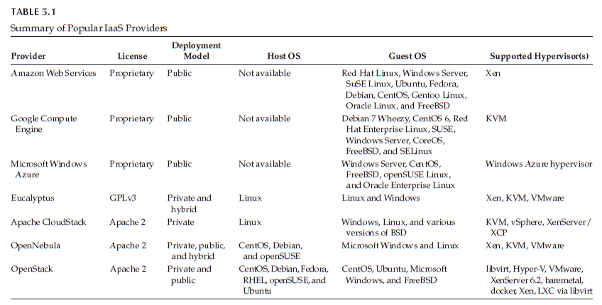

**Platform as a Service with examples of Amazon DynamoDB**

Platform as a Service (PaaS) is a cloud computing model that provides a platform allowing customers to develop, run, and manage applications without the complexity of building and maintaining the underlying infrastructure. In the PaaS model, the cloud provider hosts the hardware, software, and development tools necessary for application development, deployment, and management, while users focus on building and deploying their applications.

**2. Key Components of PaaS:**

1.**Programming languages:** PaaS providers provide a wide variety of programming languages for the developers to develop applications. Some of the popular programming languages provided by PaaS vendors are Java, Perl, PHP, Python, Ruby, Scala, Clojure and so on.

2. **Application frameworks:** PaaS vendors provide application frameworks that simplify the application development. Some of the popular application development frameworks provided by a PaaS provider include Node.js, Rails, Drupal, Joomla, WordPress, Django, EE6, Spring, Play, Sinatra, Rack, and Zend.

3**.Database:** Since every application needs to communicate with the databases, it becomes a must-have tool for every application. PaaS providers are providing databases also with their PaaS platforms. The popular databases provided by the popular PaaS vendors are ClearDB, PostgreSQL, Cloudant , Membase , MongoDB, and Redis.

4.**Other tools:** PaaS providers provide all the tools that are required to develop, test, and deploy an application.

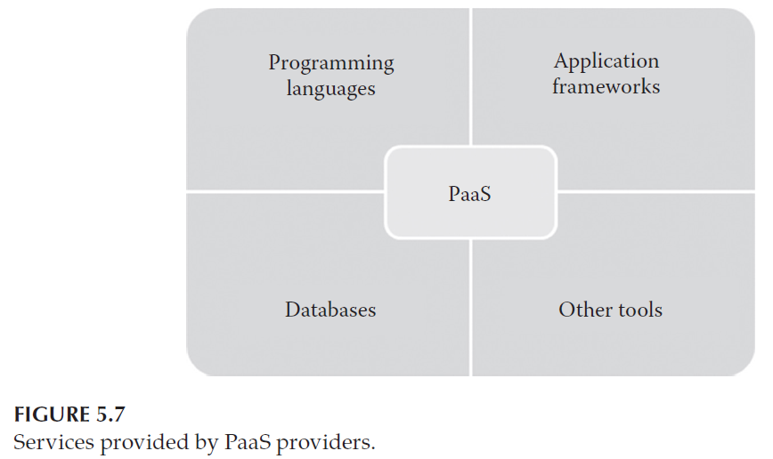

**Characteristics of PaaS**

**Characteristics of PaaS**

PaaS development platforms are different from the traditional application development platforms. The following are the essential characteristics that make PaaS unique from traditional development :

1. All in one: Most of the PaaS providers offer services to develop, test, deploy, host, and maintain applications in the same IDE. Additionally, many service providers provide all the programming languages, frameworks, databases, and other development-related services that make developers choose from a wide variety of development platforms.

2. Web access to the development platform: A typical development platform uses any IDEs for developing applications. Typically, the IDE will be installed in the developer’s machines. But, PaaS provides web access to the development platform. Using web UI,any developer can get access to the development platform. The web-based UI helps the developers create, modify, test, and deploy different applications on the same platform.

3. Offline access: A developer may not be able to connect to the Internet for a whole day to access the PaaS services. When there is no Internet connectivity, the developers should be allowed to work offline. To enable offline development, some of the PaaS providers allow the developer to synchronize their local IDE with the PaaS services. The developers can develop an application locally and deploy it online whenever they are connected to the Internet.

4. Built-in scalability: Scalability is an important requirement for the new-generation web or SaaS applications. It is very difficult to enable the dynamic scalability for any application developed using traditional development platforms. But, PaaS services provide built-in scalability to an application that is developed using any particular PaaS. This ensures that the application is capable of handling varying loads efficiently.

5. Collaborative platform: Nowadays, the development team consists of developers who are working from different places. There is a need for a common platform where the developers can collaboratively work together on the same project. Most of the PaaS services provide support for collaborative development. To enable collaboration among developers, most of the PaaS providers provide tools for project planning and communication.

6. Diverse client tools: To make the development easier, PaaS providers provide a wide variety of client tools to help the developer. The client tools include CLI, web CLI, web UI, REST API, and IDE. The developers can choose any tools of their choice. These client tools are also capable of handling billing and subscription management.

**Suitability of PaaS**

**1.** Collaborative development: To increase the time to market and development efficiency, there is a need for a common place where the development team and other stakeholders of the application can collaborate with each other. Since PaaS services provide a collaborative development environment.

2. Automated testing and deployment: Automated testing and building of an application are very useful while developing applications at a very short time frame. Most of the PaaS services offer automated testing and deployment capabilities. The development team needs to concentrate more on development rather than testing and deployment. Thus, PaaS services are the best option where there is a need for automated testing and deployment of the applications.

3.Time to market: The PaaS services follow the iterative and incremental development methodologies that ensure that the application is in the market as per the time frame given. For example, the PaaS services are the best option for application development that uses agile development methodologies. If the software vendor wants their application to be in the market as soon as possible, then the PaaS services are the best option for the development.

**Pros and Cons of PaaS,**

**Pros of PaaS:**

1. Quick development and deployment: PaaS provides all the required development and testing tools to develop, test, and deploy the software in one place. Most of the PaaS services automate the testing and deployment process as soon as the developer completes the development. This speeds up application development and deployment than traditional development platforms.

2. Reduces total cost of ownership TCO: The developers need not buy licensed development and testing tools if PaaS services are selected. Most of the traditional development platforms requires high-end infrastructure for its working, which increases the TCO of the application development company. But, PaaS allows the developers to rent the software, development platforms, and testing tools to develop, build, and deploy the application.

3. Supports agile software development: Nowadays, most of the new-generation applications are developed using agile methodologies. Many ISVs and SaaS development companies started adopting agile methodologies for application development. PaaS services support agile methodologies that the ISVs and other development companies are looking for.

4. Different teams can work together: The traditional development platform does not have extensive support for collaborative development. PaaS services support developers from different places to work together on the same project. This is possible because of the online common development platform provided by PaaS providers.

5. Ease of use: Some developers may not be familiar with the interfaces provided by the application development platform. This makes the development job a little bit difficult. But, PaaS provides a wide variety of client tools such as CLI, web CLI, web UI, APIs, and IDEs. The developers are free to choose any client tools of their choice. Especially, the web UI–based PaaS services increase the usability of the development platform for all types of developers.

6. Less maintenance overhead: In on-premise applications, the development company or software vendor is responsible for maintaining the underlying hardware. They need to recruit skilled administrators to maintain the servers. This overhead is eliminated by the PaaS services as the underlying infrastructure is maintained by the infrastructure providers. This gives freedom to developers to work on the application development.

**Cons of PaaS:**

1. **Vendor Lock-In:**Dependence on a specific PaaS provider can lead to vendor lock-in, making it challenging to migrate applications and data to another platform or back to on-premises infrastructure.
2. **Limited Control:**With PaaS, developers have less control over the underlying infrastructure and environment configurations. This can be a limitation for applications requiring customized server settings or specific hardware configurations.
3. **Compatibility Issues:**Compatibility issues may arise when integrating PaaS solutions with existing on-premises systems or third-party services, potentially requiring additional development effort.
4. **Performance Variability:**Performance can vary depending on the provider's infrastructure and the geographical location of data centers. Shared resources in multi-tenant environments can also lead to performance degradation.
5. **Security Concerns:**Although PaaS providers offer security measures, the shared responsibility model means that security also depends on how well developers implement security practices in their applications.
6. **Customization Limitations:**PaaS platforms may impose limitations on customization, particularly for applications that require unique configurations or specialized middleware.
7. **Cost Management:**While PaaS can be cost-efficient, the pay-as-you-go model may lead to unpredictable costs if not managed carefully, especially with resource-intensive applications.

**Summary of PaaS providers**

* PaaS providers are more in the IT market for public as well as the private clouds. Table 5 gives a summary of popular private and public PaaS providers.

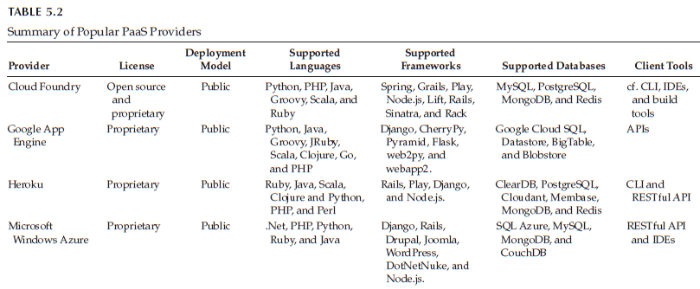

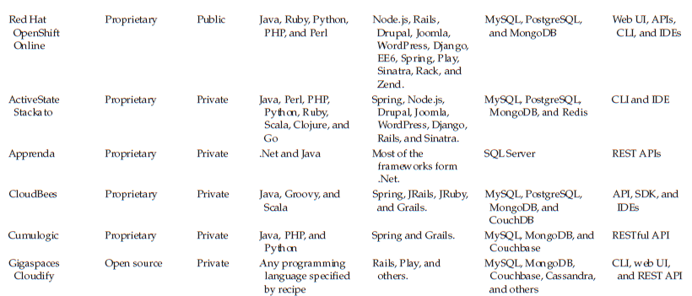

**Software as a service**

**1. What is SaaS?**

Software as a Service (SaaS) is a cloud computing model where software applications are hosted and managed by a third-party provider and made accessible to users over the internet. Instead of purchasing and installing software on individual devices or servers, users subscribe to SaaS applications on a pay-as-you-go basis, typically through a monthly or yearly subscription.

**2. How Does SaaS Work?**

In the SaaS model, the provider hosts the software application on their servers, manages the underlying infrastructure, and handles maintenance, updates, and security patches. Users access the software via a web browser or application interface, often using a variety of devices such as desktop computers, laptops, tablets, or smartphones. The provider typically follows a multi-tenant architecture, where a single instance of the software serves multiple customers while ensuring data isolation and security.

**2. Key Components of SaaS**

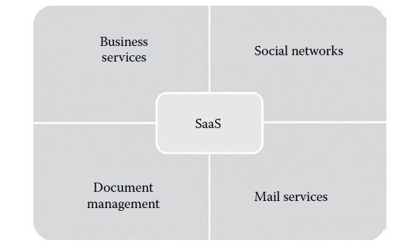

1. **Business services:** Most of the SaaS providers started providing a variety of business services that attract start-up companies. The business SaaS services include ERP, CRM, billing, sales, and human resources.

2. **Social networks:** Since social networking sites are extensively used by the general public, many social networking service providers adopted SaaS for their sustainability. Since the number of users of the social networking sites is increasing exponentially, cloud computing is the perfect match for handling the variable load.

3. **Document management:** Since most of the enterprises extensively use electronic documents, most of the SaaS providers started providing services that are used to create, manage, and track electronic documents.

4. **Mail services:** E-mail services are currently used by many people. The future growth in e-mail usage is unpredictable. To handle the unpredictable number of users and the load on e-mail services, most of the

**Characteristics of SaaS**

Software as a Service (SaaS) is a cloud-based software distribution model where applications are hosted by a third-party provider and made available to customers over the internet. This model offers several distinct characteristics that differentiate it from traditional software deployment methods. Below are the key characteristics of SaaS:

The following are the essential characteristics of SaaS services that make it unique from traditional software:

1. **One to many:** SaaS services are delivered as a one-to-many model where a single instance of the application can be shared by multiple tenants or customers.

2. **Web access:** SaaS services provide web access to the software. It allows the end user to access the application from any location if the device is connected to the Internet.

3. **Centralized management:** Since SaaS services are hosted and managed from the central location, management of the SaaS application becomes easier. Normally, the SaaS providers will perform the automatic updates that ensure that each tenant is accessing the most recent version of the application without any user-side updates.

The following are the essential characteristics of SaaS services that make it unique from traditional software:

* 1. **One to many:** SaaS services are delivered as a one-to-many model where a single instance of the application can be shared by multiple tenants or customers.
* 2. **Web access:** SaaS services provide web access to the software. It allows the end user to access the application from any location if the device is connected to the Internet.
* 3. **Centralized management:** Since SaaS services are hosted and managed from the central location, management of the SaaS application becomes easier. Normally, the SaaS providers will perform the automatic updates that ensure that each tenant is accessing the most recent version of the application without any user-side updates.
* 4. **Multidevice support:** SaaS services can be accessed from any end user devices such as desktops, laptops, tablets, smartphones, and thin clients.
* 5. **Better scalability:** Since most of the SaaS services leverage PaaS and IaaS for its development and deployment, it ensures a better scalability than the traditional software. The dynamic scaling of underlying cloud resources makes SaaS applications work efficiently even with varying loads.
* **6. High availability:** SaaS services ensure the 99.99% availability of user data as proper backup and recovery mechanisms are implemented at the back end.
* **7. API integration:** SaaS services have the capability of integrating with other software or service through standard APIs.

**SaaS Suitability**

SaaS is popular among individuals and start-up companies because of the benefits it provides. SaaS applications are the best option for the following:

* 1. On-demand software: The licensing-based software model requires buying full packaged software and increases the spending on buying software. Some of the occasionally used software does not give any ROI. Because of this, many end users are looking for a software that they can use as and when they needed , then the SaaS model is the best option.
* 2. Software for start-up companies: When using any traditional software, the end user should buy devices with minimum requirements specified by the software vendor. This increases the investment on buying hardware for start-up companies. Since SaaS services do not require high-end infrastructure for accessing, it is a suitable option for start-up companies that can reduce the initial expenditure on buying high-end hardware
* 3. Software compatible with multiple devices: Some of the applications like word processors or mail services need better accessibility from different devices. The SaaS applications are adaptable with almost all the devices.
* 4. Software with varying loads: We cannot predict the load on popular applications such as social networking sites. The user may connect or disconnect from applications anytime. It is very difficult to handle varying loads with the traditional infrastructure. With the dynamic scaling capabilities, SaaS applications can handle varying loads efficiently without disrupting the normal behavior of the application.

**Benefits of SaaS**

1. **Cost Savings:** Eliminates the need for hardware and reduces costs related to IT maintenance and upgrades.
2. **Flexibility and Scalability:** Easy to scale usage based on business needs without significant investment in infrastructure.
3. **Accessibility:** Enables access to applications from anywhere, facilitating remote work and collaboration.
4. **Automatic Updates:** Users benefit from the latest features and security updates without manual intervention.
5. **Resource Efficiency:** Frees up internal resources to focus on core business activities instead of managing software and infrastructure.

**Drawbacks of SaaS**

* 1. **Security:** Security is the major concern in migrating to SaaS application. Since the SaaS application is shared between many end users, there is a possibility of data leakage. Here, the data are stored in the service provider data center.
* 2. **Connectivity requirements:** SaaS applications require Internet connectivity for accessing it. Sometimes, the end user’s Internet connectivity might be very slow. In such situations, the user cannot access the services with ease. The dependency on high-speed Internet connection is a major problem in SaaS applications.
* 3. **Loss of control:** Since the data are stored in a third-party and off-premise location, the end user does not have any control over the data. The degree of control over the SaaS application and data is lesser than the on-premise application.

**Summary of SaaS providers**

* There are many SaaS providers who provide SaaS services such as ERP,  
  CRM, billing, document management, and mail services. Table 5.3 gives a  
  summary of popular SaaS vendors in the market

